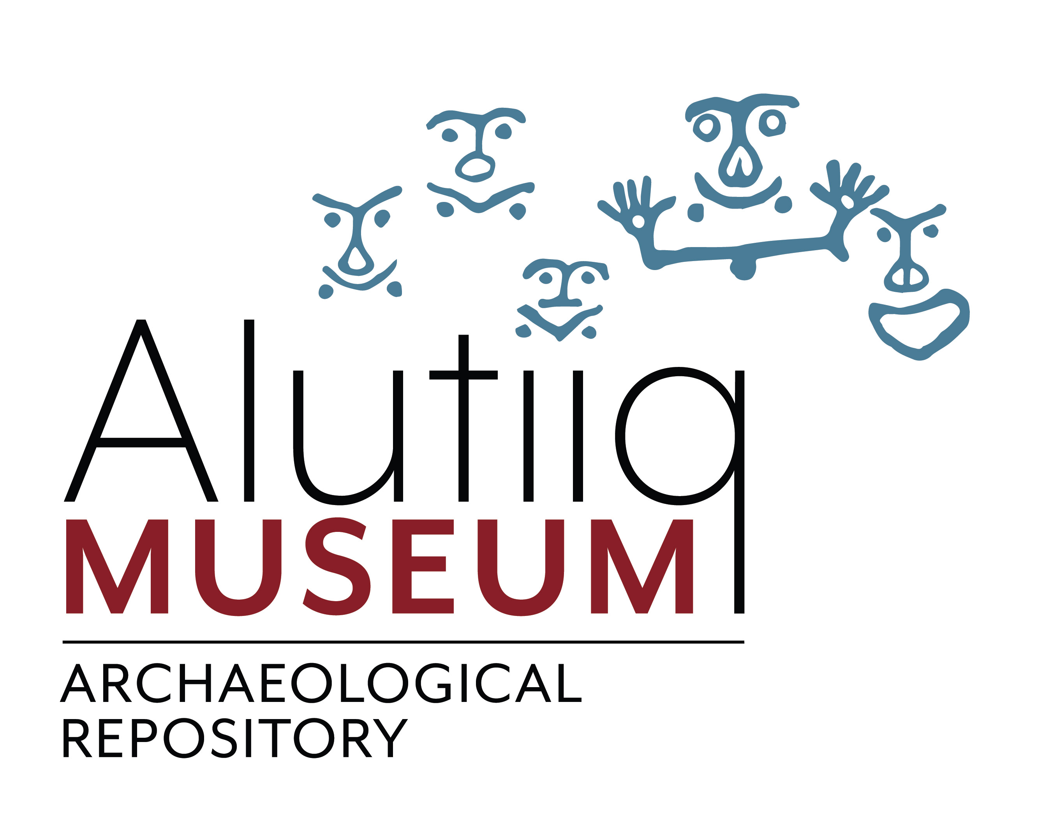
PRESS RELEASE
February 14, 2024

FROM:
Alutiiq Museum & Archaeological Repository
215 Mission Road, Suite 101, Kodiak, AK 99615
(844) 425-8844, alutiiqmuseum.org
CONTACT:
Djuna Davidson, Director of Advancement & Operations
djuna@alutiiqmuseum.org

Jim and Bonnie Dillard Named Alutiiq Museum Volunteers of the Year

Every Valentine’s Day the Alutiiq Museum shows little love for its volunteers. We are fortunate to have many friends who contribute their time and talents to our work. To highlight the importance of our volunteers, we honor one outstanding contribution with our Volunteer of the Year award. For 2023, we picked Jim and Bonnie Dillard. The Dillards worked together to make a pair of Alutiiq drums for use by students.

Long-time Kodiak educators and artists, Jim and Bonnie Dillard have supported cultural education and the Alutiiq Museum for decades. Jim was an instructor in the museum’s first carving classes and traveled to villages with Sven Hakaanson to teach mask-making. He has lectured on woodworking and made objects for our teaching collection. Bonnie has partnered with the museum to bring Alutiiq traditions to art classes with lesson plans and special projects.

In 2023, the Dillards helped again when elementary school music students asked for Alutiiq drums to use in class. Jim and Bonnie volunteered their expertise. Thanks to their kindness, two drums now spend the school year in the music department and return to the museum each summer for care.

The drums took weeks to make and were crafted in an Alutiiq way. Jim carved the handles, braces, and rim pieces. Then he soaked the rims for five weeks, steamed them, and bent them to shape. Next, he assembled each drum and used airplane fabric to cover the heads. The final step was painting. Bonnie decorated each drum in Alutiiq colors and added a painted feather to the head.

“Thanks to the Dillards, students exploring Alutiiq music now have appropriate instruments,” said the museum’s Executive Director April Laktonen Counceller. “We are very grateful for the knowledge Jim and Bonnie are helping to keep alive in the community and pass on to the next generation.”

To learn more about volunteering at the museum, please contact Djuna Davidson (844-425-8844; djuna@alutiiqmuseum.org). We welcome all volunteers, and no experience is necessary.

The Alutiiq Museum is a non-profit organization dedicated to preserving and sharing the history and living culture of the Alutiiq, an Alaska Native people. Representatives of Kodiak Alutiiq organizations govern the museum with funding from charitable contributions, memberships, grants, contracts, and sales.
#

